L3: Lab Report-MPI

1 Experiment Setup
Configuration | Configuration instructions
Hardware configuration | CPU | Intel(R) Xeon(R) Gold 6330 CPU @ 2.00GHz
 | Memory | 256 GiB
 | Storage | 1.8 TB local disk (47 GB available), 57 TB network storage (Lustre filesystem)
Software configuration | Operating System | Ubuntu 20.04 (Linux kernel 5.4.0-208-ge neric)
 | Compiler | g++ 9.4.0
 | MPI version | mpirun (Open MPI) 4.0.3

2. Performance Evaluation of Conjugate Gradient

2.1 Performance of Sequential Conjugate Gradient
Implementation Details:
The serial Conjugate Gradient (CG) implementation solves the symmetric positive definite linear system (Ax=b) iteratively. The algorithm first allocates memory for the solution vector (x), residual vector (r), search direction vector (p), and temporary vector $ω$. The initial solution is set to zero, the residual is initialized as (r=b), and the search direction is set to (p=r). The squared residual norm (ρ=r^Tr) is then computed. During each iteration, the matrix-vector multiplication (ω=Ap) is performed using nested loops over the dense matrix. The step size (α) is calculated as (ρ/(p^T ω)), after which the solution vector and residual vector are updated using (x=x+ αp) and (r=r- αω). The new residual norm (ρnew = r^Tr) is computed and compared against the convergence tolerance. If convergence has not been reached, the coefficient (β = ρnew​ / ρ) is calculated and the search direction is updated as (p=r+βp). The process repeats until either the maximum number of iterations is reached or the residual norm falls below the specified tolerance. Finally, all temporary memory is released and the approximated solution vector is returned.

Pseudocode:
Input: A (N×N SPD), b (N), max_steps, tol
x=0; r=b; p=r; rho=||r||²
for k = 1 to max_steps:
if sqrt(rho) < tol: break
omega = A * p
alpha = rho / (p^T * omega)
x = x + alpha * p
r = r - alpha * omega
rho_new = ||r||²
if sqrt(rho_new) < tol: break
beta = rho_new / rho
p = r + beta * p
rho = rho_new

Flow Chart:
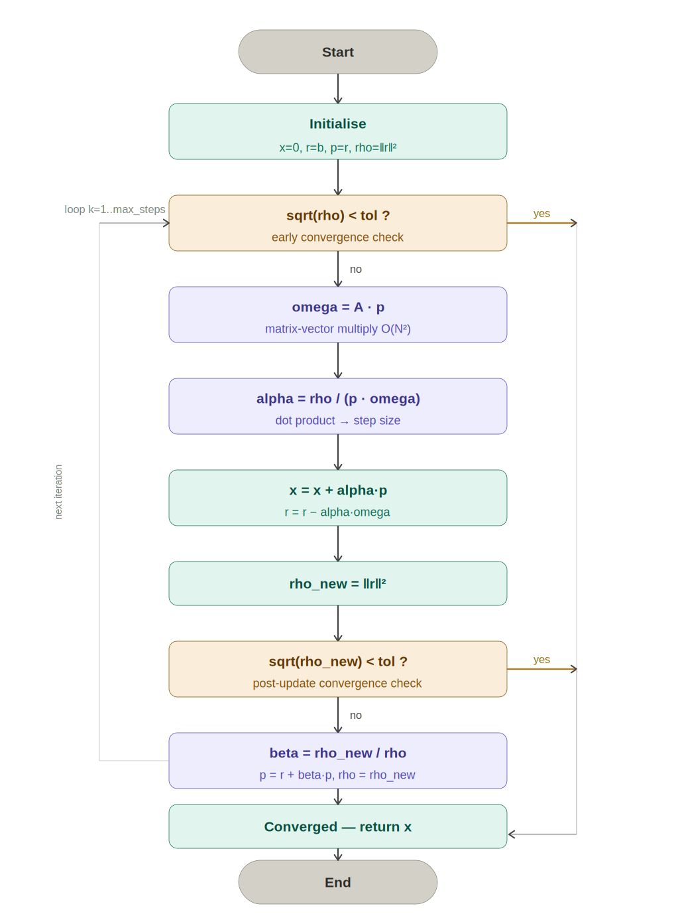

Results:

Matrix Dimension | Step Size | Execution Time (s)
1024 | 50 | 0.012412
 | 100 | 0.012389
 | 200 | 0.012394
 | 500 | 0.012397
2048 | 50 | 0.051631
 | 100 | 0.051363
 | 200 | 0.051338
 | 500 | 0.051658
4096 | 50 | 0.239446
 | 100 | 0.238972
 | 200 | 0.238996
 | 500 | 0.238898
8192 | 50 | 0.901125
 | 100 | 0.893356
 | 200 | 0.890121
 | 500 | 0.879744

The results show that execution time increases significantly as the matrix dimension grows from 1024 to 8192. This is expected because larger matrices require more computations during the matrix-vector multiplication step, which is the most expensive operation in the Conjugate Gradient algorithm.

In contrast, changing the maximum step size from 50 to 500 has almost no effect on execution time. This indicates that the solver converges before reaching the maximum number of iterations, so increasing the step limit does not increase the actual amount of work performed.

Overall, matrix size is the main factor affecting execution time, while the maximum step size has minimal impact on performance.

2.2 Performance of Parallel Conjugate Gradient
Implementation Details:

The parallel implementation distributes the matrix rows and vectors among multiple MPI processes using a one-dimensional row-wise decomposition. Each process stores only a subset of the matrix rows and the corresponding vector elements. Similar to the serial version, the local solution vector is initialized to zero, the local residual is set to the local portion of b, and the search direction is initialized from the residual. Each process computes its local contribution to the residual norm, and a global residual norm is obtained using MPI_Allreduce.

During every CG iteration, the matrix-vector multiplication Ap is performed cooperatively by all processes. Since each process owns only part of the search vector p, a ring communication pattern is used where processes exchange portions of p with neighboring processes using MPI_Isend and MPI_Recv. As each block of p arrives, the process multiplies it with the corresponding columns of its local matrix rows and accumulates the result in ω. Once the distributed matrix-vector multiplication is completed, each process computes its local contribution to the dot product p^Tω, and MPI_Allreduce is used to obtain the global value required to calculate α. The local solution and residual vectors are then updated. The new residual norm is again computed collectively using MPI_Allreduce, allowing all processes to determine convergence simultaneously. If convergence is not achieved, the search direction is updated locally and the next iteration begins. At the end of the computation, each process holds its portion of the approximated solution vector.

Problem Partitioning:

The problem is partitioned using row-wise domain decomposition. The N×N matrix is divided into contiguous blocks of rows, and each MPI process is assigned approximately N/Np rows, where Np is the number of processes. The corresponding portions of vectors b, x, r, p, and ω are stored locally by each process. This decomposition reduces memory requirements because no process needs to store the entire matrix or vectors. The workload is balanced by distributing rows as evenly as possible among all processes.
For example, for N=8192 and Np=4, each process owns 2048 consecutive rows of A, the matching slice of b, and writes its result into equation.x_star.

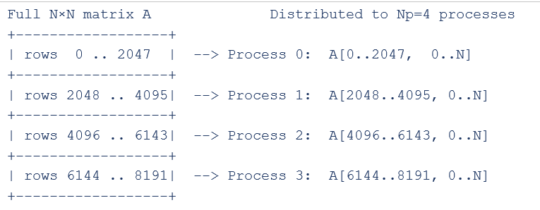

Flow Chart:
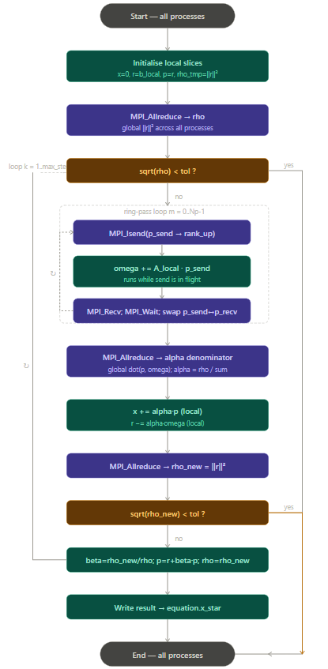
Parallel Features Used:
- MPI Cartesian communicator: MPI_Cart_create() builds a 1D virtual topology. Each process gets a coordinate that determines which rows of A it owns, simplifying neighbour addressing (rank_up, rank_down).
- Non-blocking send (MPI_Isend) : In the ring-passing loop, MPI_Isend posts the send before local computation begins. The message travels over the network while the CPU accumulates omega, meaning communication is hidden behind computation.
- Point-to-point communication (MPI_Recv): Used to receive vector segments during the ring exchange.
- Collective communication (MPI_Allreduce): Two MPI_Allreduce calls per iteration (MPI_SUM) gather global sums from all processes: one for rho = global ||r||^2 and one for the alpha denominator = global dot(p, omega). MPI_Allreduce ensures every process gets the result and can continue without a broadcast.
- MPI_Barrier: Used to perform synchronization is performed to ensure fair timing measurements across all processes.
- MPI_Wtime: Used to measure timing, which provides high-resolution wall-clock timing for MPI programs.

Optimizations Used:
First, the matrix is distributed across processes, reducing the memory footprint per process and allowing larger problem sizes to be solved. Second, a ring-based communication strategy is used for the matrix-vector multiplication, avoiding the need to broadcast the entire search vector to every process. Third, non-blocking communication (MPI_Isend) allows communication to overlap partially with computation, reducing communication overhead. Fourth, only the necessary global reductions are performed using MPI_Allreduce, minimizing synchronization costs while ensuring correctness. Finally, the code is compiled with the -O3 optimization flag, enabling compiler-level optimizations such as loop optimization and instruction-level improvements to enhance execution performance.
Results:

Matrix Size = 1024
Step Size | Process Number | Execution Time (s) | Speed Up
50 | 1 | 0.012361 | 1.00412588
 | 2 | 0.006126 | 2.026118185
 | 4 | 0.004014 | 3.092177379
 | 8 | 0.002507 | 4.950937375
 | 16 | 0.002312 | 5.368512111
 | 32 | 0.001112 | 11.1618705
 | 64 | 0.001357 | 9.146647015
100 | 1 | 0.012339 | 1.004052192
 | 2 | 0.006130 | 2.021044046
 | 4 | 0.003980 | 3.11281407
 | 8 | 0.002204 | 5.621143376
 | 16 | 0.001850 | 6.696756757
 | 32 | 0.001451 | 8.538249483
 | 64 | 0.002293 | 5.402965547
200 | 1 | 0.012338 | 1.004538823
 | 2 | 0.006117 | 2.026156613
 | 4 | 0.003188 | 3.88770389
 | 8 | 0.002027 | 6.114454859
 | 16 | 0.001521 | 8.148586456
 | 32 | 0.001207 | 10.26843413
 | 64 | 0.001984 | 6.246975806
500 | 1 | 0.012333 | 1.005189329
 | 2 | 0.006112 | 2.028304974
 | 4 | 0.004158 | 2.981481481
 | 8 | 0.002618 | 4.735294118
 | 16 | 0.001738 | 7.132911392
 | 32 | 0.001437 | 8.627000696
 | 64 | 0.001888 | 6.566207627

Matrix Size = 2048
Step Size | Process Number | Execution Time (s) | Speed Up
50 | 1 | 0.050907 | 1.014222013
 | 2 | 0.025467 | 2.027368752
 | 4 | 0.012273 | 4.206876884
 | 8 | 0.005690 | 9.073989455
 | 16 | 0.003457 | 14.93520393
 | 32 | 0.002000 | 25.8155
 | 64 | 0.003914 | 13.19136433
100 | 1 | 0.050829 | 1.010505814
 | 2 | 0.025466 | 2.016924527
 | 4 | 0.012323 | 4.168059726
 | 8 | 0.005544 | 9.26461039
 | 16 | 0.003345 | 15.35515695
 | 32 | 0.002400 | 21.40125
 | 64 | 0.002971 | 17.28811848
200 | 1 | 0.050884 | 1.008922255
 | 2 | 0.025464 | 2.016101162
 | 4 | 0.012280 | 4.180618893
 | 8 | 0.005543 | 9.261771604
 | 16 | 0.003236 | 15.86464771
 | 32 | 0.002094 | 24.51671442
 | 64 | 0.002271 | 22.60590048
500 | 1 | 0.050808 | 1.016729649
 | 2 | 0.025454 | 2.029464917
 | 4 | 0.012296 | 4.201203643
 | 8 | 0.005621 | 9.190179683
 | 16 | 0.003164 | 16.32680152
 | 32 | 0.003125 | 16.53056
 | 64 | 0.002531 | 20.41011458

Matrix Size = 4096
Step Size | Process Number | Execution Time (s) | Speed Up
50 | 1 | 0.211046 | 1.134567819
 | 2 | 0.107606 | 2.22521049
 | 4 | 0.053304 | 4.492083146
 | 8 | 0.027479 | 8.713781433
 | 16 | 0.015389 | 15.55955553
 | 32 | 0.008379 | 28.57691849
 | 64 | 0.010357 | 23.11924302
100 | 1 | 0.210723 | 1.134057507
 | 2 | 0.107709 | 2.218681819
 | 4 | 0.053435 | 4.472199869
 | 8 | 0.027395 | 8.723197664
 | 16 | 0.015381 | 15.53683116
 | 32 | 0.008475 | 28.19728614
 | 64 | 0.011166 | 21.40175533
200 | 1 | 0.210815 | 1.133676446
 | 2 | 0.107627 | 2.220595204
 | 4 | 0.053661 | 4.453811893
 | 8 | 0.027403 | 8.72152684
 | 16 | 0.015512 | 15.40716864
 | 32 | 0.008502 | 28.11056222
 | 64 | 0.010697 | 22.34233897
500 | 1 | 0.210820 | 1.133184707
 | 2 | 0.107755 | 2.217047933
 | 4 | 0.053491 | 4.46613449
 | 8 | 0.027421 | 8.712227855
 | 16 | 0.015397 | 15.51587972
 | 32 | 0.008432 | 28.3323055
 | 64 | 0.010234 | 23.34356068

Matrix Size = 8192
Step Size | Process Number | Execution Time (s) | Speed Up
50 | 1 | 0.904768 | 0.995973553
 | 2 | 0.461279 | 1.953535713
 | 4 | 0.218579 | 4.122651307
 | 8 | 0.111515 | 8.080751468
 | 16 | 0.063541 | 14.18178814
 | 32 | 0.057533 | 15.66275007
 | 64 | 0.068135 | 13.22558157
100 | 1 | 0.904690 | 0.987471952
 | 2 | 0.460664 | 1.939278954
 | 4 | 0.218456 | 4.089409309
 | 8 | 0.111493 | 8.012664472
 | 16 | 0.063387 | 14.09367851
 | 32 | 0.057248 | 15.60501677
 | 64 | 0.070488 | 12.67387357
200 | 1 | 0.908921 | 0.979316134
 | 2 | 0.465305 | 1.912983957
 | 4 | 0.218734 | 4.069422221
 | 8 | 0.111385 | 7.991390223
 | 16 | 0.063413 | 14.03688518
 | 32 | 0.057643 | 15.44196173
 | 64 | 0.060921 | 14.61107007
500 | 1 | 0.904624 | 0.972496861
 | 2 | 0.465306 | 1.890678392
 | 4 | 0.218774 | 4.021245669
 | 8 | 0.111417 | 7.895958426
 | 16 | 0.063227 | 13.9140557
 | 32 | 0.057690 | 15.24950598
 | 64 | 0.072376 | 12.15518957

The results show that the parallel Conjugate Gradient implementation achieves significant performance improvement as the number of processes increases. For all matrix sizes, the execution time decreases and the speedup increases when moving from 1 process to 32 processes. This indicates that the workload is effectively distributed among the MPI processes and that the parallelization strategy successfully reduces the computation time.

For larger matrices (2048, 4096, and 8192), the speedup scales almost linearly up to 32 processes. The best performance is observed for the 4096×4096 matrix, which achieves a speedup of approximately 28× when using 32 processes. Similarly, the 2048×2048 matrix reaches a speedup of around 25×, while the 8192×8192 matrix achieves a speedup of about 15×. These results demonstrate that larger computational workloads benefit more from parallel execution because the communication overhead becomes relatively smaller compared to the computation cost.

However, when the number of processes increases from 32 to 64, the speedup either decreases or shows only a small improvement. This behavior can be seen clearly in both the tables and line charts. The reason is that communication and synchronization overheads become more significant at higher process counts. Operations such as MPI_Allreduce, message passing during the ring communication for matrix-vector multiplication, and process synchronization introduce additional costs that limit scalability.

The effect of the step size is minimal across all experiments. The speedup curves for step sizes 50, 100, 200, and 500 are very similar, indicating that the convergence behavior of the Conjugate Gradient algorithm is largely independent of the maximum step limit. Since the solver typically converges before reaching the maximum number of iterations, increasing the step size does not significantly affect the execution time or speedup.

Overall, the parallel implementation demonstrates good scalability and efficiency up to 32 processes. Beyond this point, communication overhead begins to dominate, causing diminishing returns in performance improvement. The results confirm that MPI-based parallelization effectively accelerates the Conjugate Gradient solver, particularly for larger matrix dimensions.

3.1 Performance of Sequential N-body

3.1.1 Implementation Details
In the serial implementation, the program simulates the motion of n particles over a number of time steps by repeatedly computing gravitational interactions and updating particle states. At each timestep, it first computes the net force on every particle using a double loop over all particle pairs, applying Newton’s law of gravitation to calculate the pairwise force and summing contributions in both x and y directions. This results in an O(n²) force computation phase. After all forces are computed, the program updates each particle’s velocity and position using a simple time-stepping scheme: the velocity is updated based on acceleration (force divided by mass), and the position is updated using the updated velocity and timestep size Δt. This process is repeated sequentially for all timesteps, producing the final positions and velocities.

Pseudocode:
// runs on rank 0 only
for step = 1 to n_steps:

// Phase 1: forces
for part = 0 to n−1:
forces[part] = {0, 0}
for k = 0 to n−1:
if k == part: skip
dx = pos[part].x − pos[k].x
dy = pos[part].y − pos[k].y
len = sqrt(dx²+dy²)
fact = −G·m_p·m_k / len³
forces[part] += fact·(dx,dy)

// Phase 2: update
for part = 0 to n−1:
pos[part] += Δt · vel[part]
vel[part] += (Δt/m) · forces[part]

if DEBUG && last step:
Output_serial()

Flow Chart:
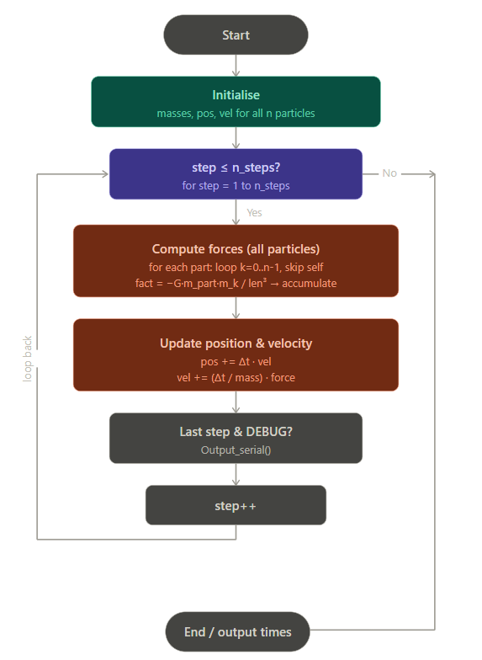

3.1.2 Performance Results
Number of Particles | Time-step Length | Number of Time-steps | Execution Time
128 | 1 | 50 | 0.005094
 |  | 100 | 0.007243
 |  | 200 | 0.013305
 |  | 500 | 0.033319
256 | 1 | 50 | 0.013235
 |  | 100 | 0.026459
 |  | 200 | 0.052850
 |  | 500 | 0.132108
512 | 1 | 50 | 0.052713
 |  | 100 | 0.105283
 |  | 200 | 0.210925
 |  | 500 | 0.527627
1024 | 1 | 50 | 0.210082
 |  | 100 | 0.421049
 |  | 200 | 0.842046
 |  | 500 | 2.105209

The serial implementation results show that the execution time increases steadily as both the number of particles and the number of timesteps increase. For a fixed number of particles, doubling the number of timesteps approximately doubles the execution time. For example, with 1024 particles, the runtime increases from 0.210 seconds for 50 timesteps to 0.421 seconds for 100 timesteps, 0.842 seconds for 200 timesteps, and 2.105 seconds for 500 timesteps. This indicates that the simulation performs a similar amount of work during each timestep, resulting in a nearly linear relationship between execution time and the number of timesteps.

The results also show that the execution time grows much faster as the number of particles increases. For instance, at 100 timesteps, increasing the particle count from 128 to 256 approximately quadruples the runtime from 0.007 seconds to 0.026 seconds, while increasing from 256 to 512 and from 512 to 1024 produces a similar fourfold increase. This behavior is expected because the force computation requires every particle to interact with every other particle, giving the algorithm a time complexity of O(n²). Therefore, doubling the number of particles results in roughly four times more force calculations.

Overall, the serial results confirm the expected computational behavior of the n-body simulation. The runtime scales linearly with the number of timesteps and quadratically with the number of particles, demonstrating that the pairwise force calculation is the dominant cost in the simulation. This increasing computational cost is the primary motivation for using MPI parallelization to distribute the workload across multiple processes and reduce execution time.

3.2 Performance of Parallel N-body

3.2.1 Implementation Details
In the parallel implementation, the particles are divided among MPI processes using a block decomposition, where each process is responsible for a contiguous subset of particles determined by its rank. Each process computes forces and updates only its local particles, reducing the computational workload per process from O(n²) to approximately O(n²/p). However, because gravitational force depends on all particles, each process still requires global position information. Therefore, after each timestep, an MPI_Allgather operation is used to synchronize updated positions across all processes, ensuring consistency for the next force computation.

Partitioning:
The n particles are divided into p equal blocks using a 1-D block distribution, where each process owns loc_n = n / p consecutive particles. Process rank r is responsible for global particle indices r * loc_n to (r+1) * loc_n - 1. This mapping is computed on the fly inside the loops as part = my_rank * loc_n + loc_part. The initial velocities are distributed to each process using MPI_Scatter, while masses and positions are broadcast to all processes using MPI_Bcast since every process needs the full arrays to compute forces correctly.

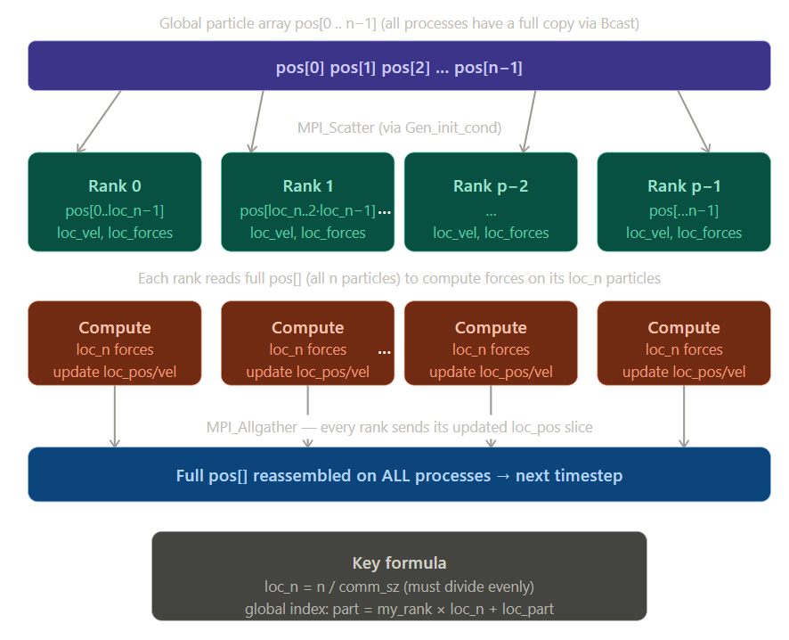

Parallel Features Used:
- MPI_Bcast shares the initial masses and position arrays to all processes, and also distributes the program arguments (n, n_steps, delta_t).
- MPI_Scatter distributes the initial velocity array so each process receives exactly its loc_n velocities.
- MPI_Allgather is invoked at the end of every timestep to collect each process's updated local positions and reassemble the complete pos[] array on all processes, ensuring correct force computation in the next step.
- MPI_Gather is used inside the debug output function to collect velocities back to rank 0 for printing.
- MPI_Barrier is placed before and after the parallel simulation to ensure all processes start and finish together, making the MPI_Wtime measurement on rank 0 an accurate wall-clock time for the full parallel execution.

Optimizations:
Three optimisations are applied. First, loc_pos is not a separate array but a pointer directly into the correct slice of the global pos[] array (loc_pos = pos + my_rank * loc_n), so writing to loc_pos automatically updates pos[] in-place with no extra copy, and MPI_Allgather can gather directly into the right positions. Second, a derived MPI datatype vect_mpi_t is created using MPI_Type_contiguous to represent the 2-element double vector, allowing the 2-D position and velocity vectors to be sent in a single MPI operation rather than two separate scalar transfers. Third, the Makefile compiles with -O3, which enables aggressive compiler optimisations including loop unrolling and auto-vectorisation on the inner force computation loop, which is the hottest code path at O(n²) per timestep.

Pseudocode:
MPI_Barrier() // sync timer
for step = 1 to n_steps:

// Phase 1: local forces only
for loc_part = 0 to loc_n−1:
part = my_rank·loc_n + loc_part
loc_forces[loc_part] = {0,0}
for k = 0 to n−1:
if k == part: skip
// same Newton formula
loc_forces[loc_part] += …

// Phase 2: local update
for loc_part = 0 to loc_n−1:
part = my_rank·loc_n + loc_part
loc_pos[loc_part] += Δt · loc_vel[loc_part]
loc_vel[loc_part] += (Δt/m) · loc_forces[loc_part]

MPI_Allgather(loc_pos → pos)

if DEBUG && last step:
Output_parallel()
MPI_Barrier() // stop timer
Flow Chart:

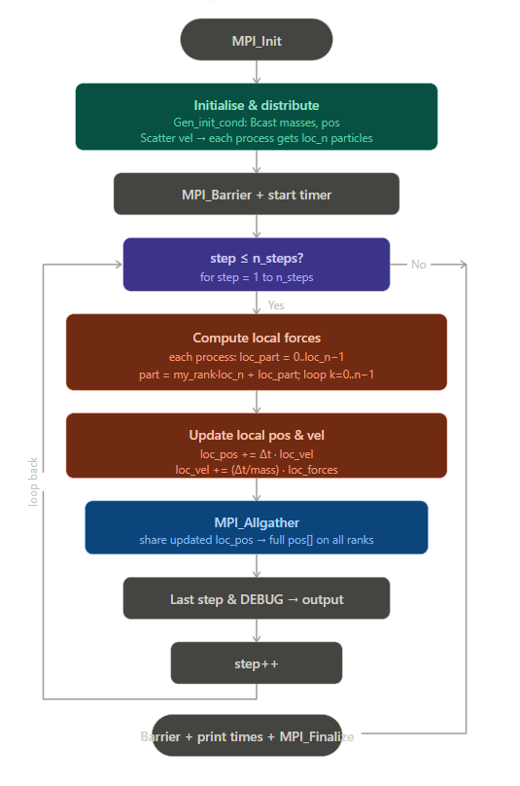

3.2.2 Performance Results
Number of Particles: 128
Number of time-steps | Time-step Length | Process Number | Execution Time | Speed Up
50 | 1 | 1 | 0.005083 | 1.002164076
 |  | 2 | 0.003669 | 1.388389207
 |  | 4 | 0.002842 | 1.792399719
 |  | 8 | 0.002002 | 2.544455544
 |  | 16 | 0.001499 | 3.39826551
 |  | 32 | 0.001573 | 3.238397966
 |  | 64 | 0.003689 | 1.380862022
100 | 1 | 1 | 0.009128 | 0.79349255
 |  | 2 | 0.006304 | 1.148953046
 |  | 4 | 0.006154 | 1.176958076
 |  | 8 | 0.003651 | 1.983840044
 |  | 16 | 0.002551 | 2.839278714
 |  | 32 | 0.002463 | 2.940722696
 |  | 64 | 0.006782 | 1.067974049
200 | 1 | 1 | 0.016833 | 0.790411691
 |  | 2 | 0.010808 | 1.231032568
 |  | 4 | 0.006331 | 2.101563734
 |  | 8 | 0.005611 | 2.371235074
 |  | 16 | 0.004919 | 2.704818052
 |  | 32 | 0.004183 | 3.180731532
 |  | 64 | 0.008844 | 1.504409769
500 | 1 | 1 | 0.035891 | 0.928338581
 |  | 2 | 0.021341 | 1.561267045
 |  | 4 | 0.013599 | 2.450106625
 |  | 8 | 0.010470 | 3.182330468
 |  | 16 | 0.010160 | 3.279429134
 |  | 32 | 0.008544 | 3.899695693
 |  | 64 | 0.025042 | 1.330524718

Number of Particles: 256
Number of time-steps | Time-step Length | Process Number | Execution Time | Speed Up
50 | 1 | 1 | 0.015730 | 0.841385887
 |  | 2 | 0.010582 | 1.250708751
 |  | 4 | 0.010556 | 1.253789314
 |  | 8 | 0.005926 | 2.233378333
 |  | 16 | 0.003350 | 3.950746269
 |  | 32 | 0.002676 | 4.945814649
 |  | 64 | 0.004893 | 2.704884529
100 | 1 | 1 | 0.029971 | 0.882820059
 |  | 2 | 0.016466 | 1.606886918
 |  | 4 | 0.014268 | 1.854429493
 |  | 8 | 0.010171 | 2.60141579
 |  | 16 | 0.006771 | 3.90769458
 |  | 32 | 0.004671 | 5.664525797
 |  | 64 | 0.007388 | 3.581348132
200 | 1 | 1 | 0.055230 | 0.956907478
 |  | 2 | 0.030924 | 1.709028586
 |  | 4 | 0.023976 | 2.204287621
 |  | 8 | 0.017198 | 3.073031748
 |  | 16 | 0.011412 | 4.631090081
 |  | 32 | 0.008232 | 6.420068027
 |  | 64 | 0.011252 | 4.696942766
500 | 1 | 1 | 0.135619 | 0.974111297
 |  | 2 | 0.073093 | 1.807396057
 |  | 4 | 0.040579 | 3.255575544
 |  | 8 | 0.027201 | 4.856733208
 |  | 16 | 0.020930 | 6.311896799
 |  | 32 | 0.014426 | 9.157632053
 |  | 64 | 0.027795 | 4.752941176

Number of Particles: 512
Number of time-steps | Time-step Length | Process Number | Execution Time | Speed Up
50 | 1 | 1 | 0.055018 | 0.95810462
 |  | 2 | 0.030253 | 1.742405712
 |  | 4 | 0.018567 | 2.839069317
 |  | 8 | 0.011891 | 4.433016567
 |  | 16 | 0.010215 | 5.160352423
 |  | 32 | 0.006167 | 8.547592022
 |  | 64 | 0.010909 | 4.832065267
100 | 1 | 1 | 0.108385 | 0.971379803
 |  | 2 | 0.056865 | 1.851455201
 |  | 4 | 0.036536 | 2.881623604
 |  | 8 | 0.021619 | 4.869929229
 |  | 16 | 0.016216 | 6.492538234
 |  | 32 | 0.010005 | 10.52303848
 |  | 64 | 0.013842 | 7.606054038
200 | 1 | 1 | 0.212449 | 0.992826514
 |  | 2 | 0.110894 | 1.902041589
 |  | 4 | 0.062166 | 3.392931828
 |  | 8 | 0.036900 | 5.716124661
 |  | 16 | 0.024706 | 8.537399822
 |  | 32 | 0.017242 | 12.2332096
 |  | 64 | 0.019362 | 10.89376098
500 | 1 | 1 | 0.525246 | 1.004533114
 |  | 2 | 0.269942 | 1.95459395
 |  | 4 | 0.140341 | 3.759606957
 |  | 8 | 0.077370 | 6.819529533
 |  | 16 | 0.047743 | 11.05140021
 |  | 32 | 0.031721 | 16.63336591
 |  | 64 | 0.044985 | 11.7289541

Number of Particles: 1024
Number of time-steps | Time-step Length | Process Number | Execution Time | Speed Up
50 | 1 | 1 | 0.212267 | 0.98970636
 |  | 2 | 0.111119 | 1.890603767
 |  | 4 | 0.063165 | 3.325924167
 |  | 8 | 0.035397 | 5.935022742
 |  | 16 | 0.022572 | 9.307194755
 |  | 32 | 0.015761 | 13.32923038
 |  | 64 | 0.017999 | 11.67187066
100 | 1 | 1 | 0.421946 | 0.997874136
 |  | 2 | 0.214305 | 1.964718509
 |  | 4 | 0.113432 | 3.711906693
 |  | 8 | 0.063302 | 6.651432814
 |  | 16 | 0.037272 | 11.29665701
 |  | 32 | 0.023132 | 18.20201453
 |  | 64 | 0.032426 | 12.98491951
200 | 1 | 1 | 0.837665 | 1.005230014
 |  | 2 | 0.426263 | 1.97541424
 |  | 4 | 0.223327 | 3.770462147
 |  | 8 | 0.117644 | 7.157577097
 |  | 16 | 0.065292 | 12.89661827
 |  | 32 | 0.039321 | 21.41466392
 |  | 64 | 0.060747 | 13.86152403
500 | 1 | 1 | 2.090864 | 1.0068608
 |  | 2 | 1.057327 | 1.991067097
 |  | 4 | 0.538919 | 3.906355129
 |  | 8 | 0.280168 | 7.514095114
 |  | 16 | 0.148661 | 14.16113843
 |  | 32 | 0.085256 | 24.69279581
 |  | 64 | 0.155042 | 13.57831426

The results show that the parallel MPI implementation achieves increasingly better performance as both the number of particles and the number of timesteps increase. For all particle sizes (128, 256, 512, and 1024), the execution time decreases as more processes are used, demonstrating that the computational workload is being successfully distributed among multiple MPI processes. Since the force calculation dominates the runtime and has a computational complexity of O(n²), larger particle counts provide more work per process, allowing the parallel implementation to utilize additional processors more effectively.

For the smallest problem size of 128 particles, the speedup is relatively limited, reaching only about 3–4× at 32 processes before declining significantly at 64 processes. This behavior indicates that communication and synchronization overhead become comparable to or even exceed the computation time. Because each process has only a small number of particles to compute, the cost of collective communication operations such as `MPI_Allgather` reduces the benefit of adding more processes. As a result, increasing the process count beyond 32 leads to diminishing returns and eventually a decrease in performance.

As the particle count increases to 256 and 512 particles, the scalability improves noticeably. The speedup curves rise more steadily with increasing process count, reaching approximately 9× for 256 particles and over 16× for 512 particles at 32 processes when using 500 timesteps. In these cases, the larger computational workload better amortizes the communication overhead. The force calculations occupy a greater proportion of the total execution time, making parallelization more effective and allowing the program to benefit from additional processing resources.

The best performance is observed for 1024 particles, where the speedup reaches approximately 24.7× using 32 processes and 500 timesteps. Similar trends are observed for the other timestep counts, with speedup consistently increasing as more processes are added up to 32. This demonstrates strong scalability for larger problem sizes because each process performs a substantial amount of computation before synchronization occurs. The results indicate that the parallel implementation is most efficient when the ratio of computation to communication is high.

Another clear trend is that increasing the number of timesteps improves speedup for a fixed particle count. For example, with 1024 particles, the speedup at 32 processes increases from about 13.3× for 50 timesteps to approximately 24.7× for 500 timesteps. This occurs because longer simulations spend more time performing force calculations while the initialization and other fixed overheads remain relatively constant. Consequently, the parallel overhead becomes a smaller fraction of the total runtime, resulting in higher parallel efficiency.

Across all four graphs, the speedup generally peaks at 32 processes and then drops when the process count increases to 64. This decline is a common characteristic of strong scaling experiments. At 64 processes, each process is assigned fewer particles, reducing the amount of useful computation while communication costs continue to increase. The frequent `MPI_Allgather` operations required after every timestep become a larger portion of the total runtime, leading to reduced efficiency and lower speedup. For example, with 1024 particles and 500 timesteps, the speedup drops from approximately 24.7× at 32 processes to 13.6× at 64 processes.

Overall, the results demonstrate that the MPI-based parallel n-body implementation successfully accelerates the simulation and scales well for larger particle counts and longer simulations. The best performance is achieved with large workloads and around 32 processes, where the computation-to-communication ratio is most favorable. Beyond this point, communication overhead and synchronization costs begin to dominate, limiting further scalability and causing performance degradation at 64 processes. These observations are consistent with the expected behavior of an all-to-all n-body algorithm that relies on collective communication to maintain global particle position information.

